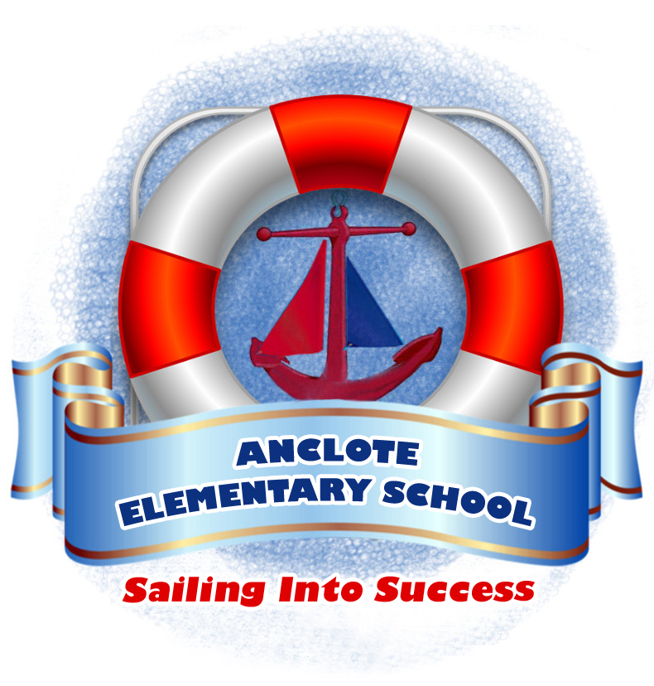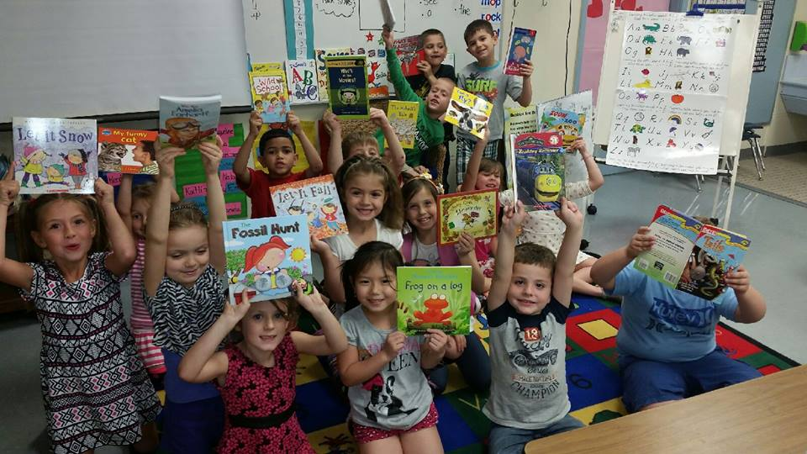

3610 Madison Street  
New Port Richey, FL 346652

aes.pasco.k12.fl.us

www.facebook.com/ancloteelementary

Anclote Elementary School

🙞 🙜

School Hours:

Free Breakfast for All Students: 9:20- 9:40

Students may enter the

classroom: 9:30

Start of the School Day 9:40

Tardy Bell: 9:40

Note: Students should arrive at

school no earlier that 9:15.

Students arriving after 9:45 will

be marked as tardy.

Anclote Elementary School

“Anchored in Success”

AES Mission:

At Anclote Elementary our

staff, parents, and community

are committed to providing a

quality education for all

students to become lifelong

learners and responsible

individuals.

### Mrs. Kleinsorge, Principal

### Mrs. Pitkoff,

### Assistant Principal

🙞 🙜

2016-2017

Anclote Elementary Parent Involvement Plan

Make sure to attend the Open House and Annual Title I Meeting to meet with your child’s teacher and learn more about Title I

Review the Family Involvement Plan

Review and Sign the Family/School Compact

Look for more information about other Family Events and Academic Nights

#### Open House and Annual Title I Meeting

#### Held in September

# Events

Each year AES develops a Parent Involvement Plan in conjunction with the input of parent surveys and various groups such as the School Advisory Council (SAC) and Parent Teacher Organization (PTO).

Parent surveys were completed at the end of last year to collect input from parents on activities, trainings, and materials needed to help their children succeed. Results of parent surveys are reviewed by the SAC when developing the School Improvement Plan (SIP) and the Parent Involvement Plan (PIP). Using this data the members of the SAC committee will consider how to use Title I and State Lottery funds to improve school programs.

Parent involvement is essential to helping our students succeed. Through various activities, such as our School Advisory Council and Parent Teacher Organization, parents provide essential feedback to assist in our school’s improvements. We also encourage you to complete post-event surveys at the conclusion of most of our school-wide events, as well as a final survey at the end of the school year. Your input is important to us.

Links to both the School Improvement Plan and the Parent Involvement Plan can be found on our school website.

## Parent Involvement Plan

In response to parent input, Anclote Elementary continues to refine our school programs and events. The school continues to provide flexible meeting and training times throughout the year by scheduling morning, afternoon, and evening meetings and workshops. These opportunities are in response to parent input.

* Student of the Month Celebration
* Family Resource Center
* Academic Nights
* Facebook

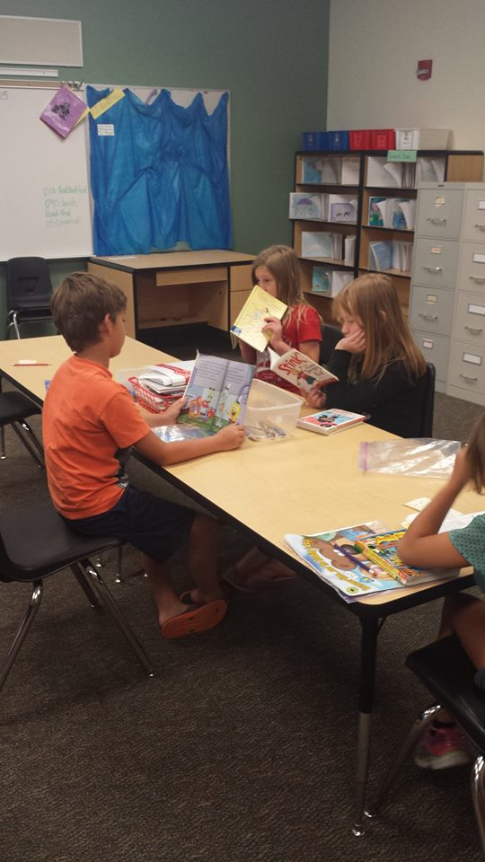

# How does AES use parent input?