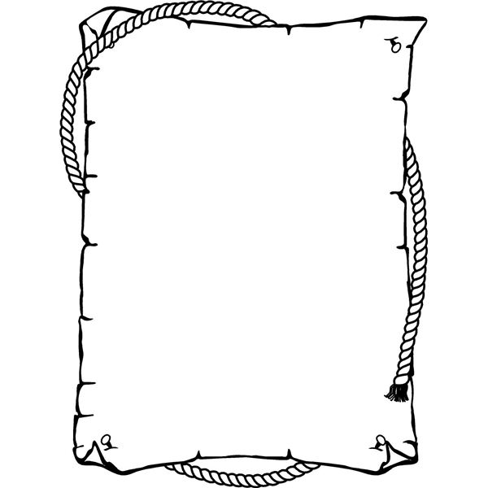**Anclote Elementary School Supply Lists**

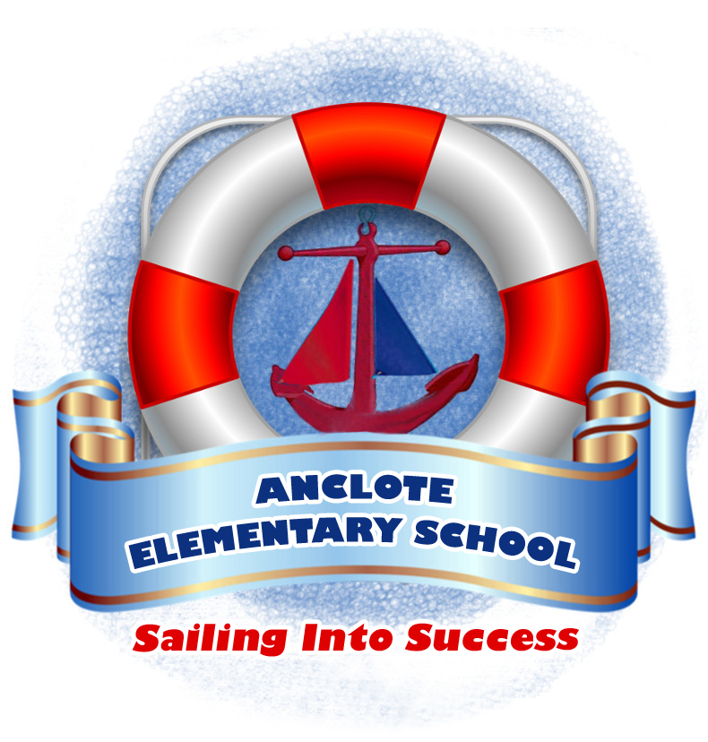

**Kindergarten**

*1 box of tissues

*3 boxes of Crayola crayons

*yellow #2 pencils

*1 backpack (no wheels)

*at least 4 glue sticks

**Grade 1**

*1 standard size backpack (no wheels)

*3 boxes of Crayola crayons

*3 multipacks #2 pencils (at least 12 per pack)

*1 box of 10 Crayola Markers

* at least 6 glue sticks

*1 box of tissues

*2 folders with prongs

*4 Expo markers

**Grade 2**

*1 box of crayons

*1 box of #2 pencils

*1 standard size crayon/pencil box (8.5x5 in.)

*1 box of tissues

*1 bottle of hand sanitizer

*1 standard size backpack (no wheels)

*6 glue sticks

**Grade 3**

*1 box of crayons

*3 dozen #2 pencils

*1 standard size crayon/pencil box (8.5x5 in.)

*1 box of tissues

*1 pkg. wide-ruled paper

*1 composition notebook

*4 two-pocket folders (1 blue, 1 green, 1 red, 1 yellow)

*1 clipboard

*1 standard size backpack (no wheels)

*6 glue sticks



**Grade 4**

*1 standard size backpack (no wheels)

*1 pencil box or bag

*2 highlighters

*2 glue sticks

*4 dry erase markers

*2 dozen sharpened pencils (minimum)

*2 packs of college-ruled loose leaf paper

*2 1-inch binders

*1 large box of tissues

**Grade 5**

*2 packs of college-ruled lined paper

* #2 pencils (enough supply for all year)

*2 boxes of Kleenex brand tissues

*1 pkg. colored pens (other than blue or black ink)

*1 package of crayons, markers, or colored pencils

*2 plain (no pictures) folders WITH prongs (any color)

* 32 plain (no pictures) folders without prongs. Colors preferred:

10 green folders (without prongs)

12 orange folders (without prongs)

**Self-Contained Academic Classes**

*1 package of 12 #2 pencils

*2 packages of loose leaf paper (wide-rule)

*2 boxes of tissues

**Additional supplies for Self-Contained Academic:**

**Kindergarten-3rd grade**

*2 packages of baby wipes

**Grades 4 & 5**

*2 composition books

*3 pocket folders